MILO - ALL STAR JUNIOR SQUASH CHAMPIONSHIPS 2012
28th May to 2nd June 2012

PETALING JAYA, SELANGOR – MALAYSIA

Sanctioned by SRAM

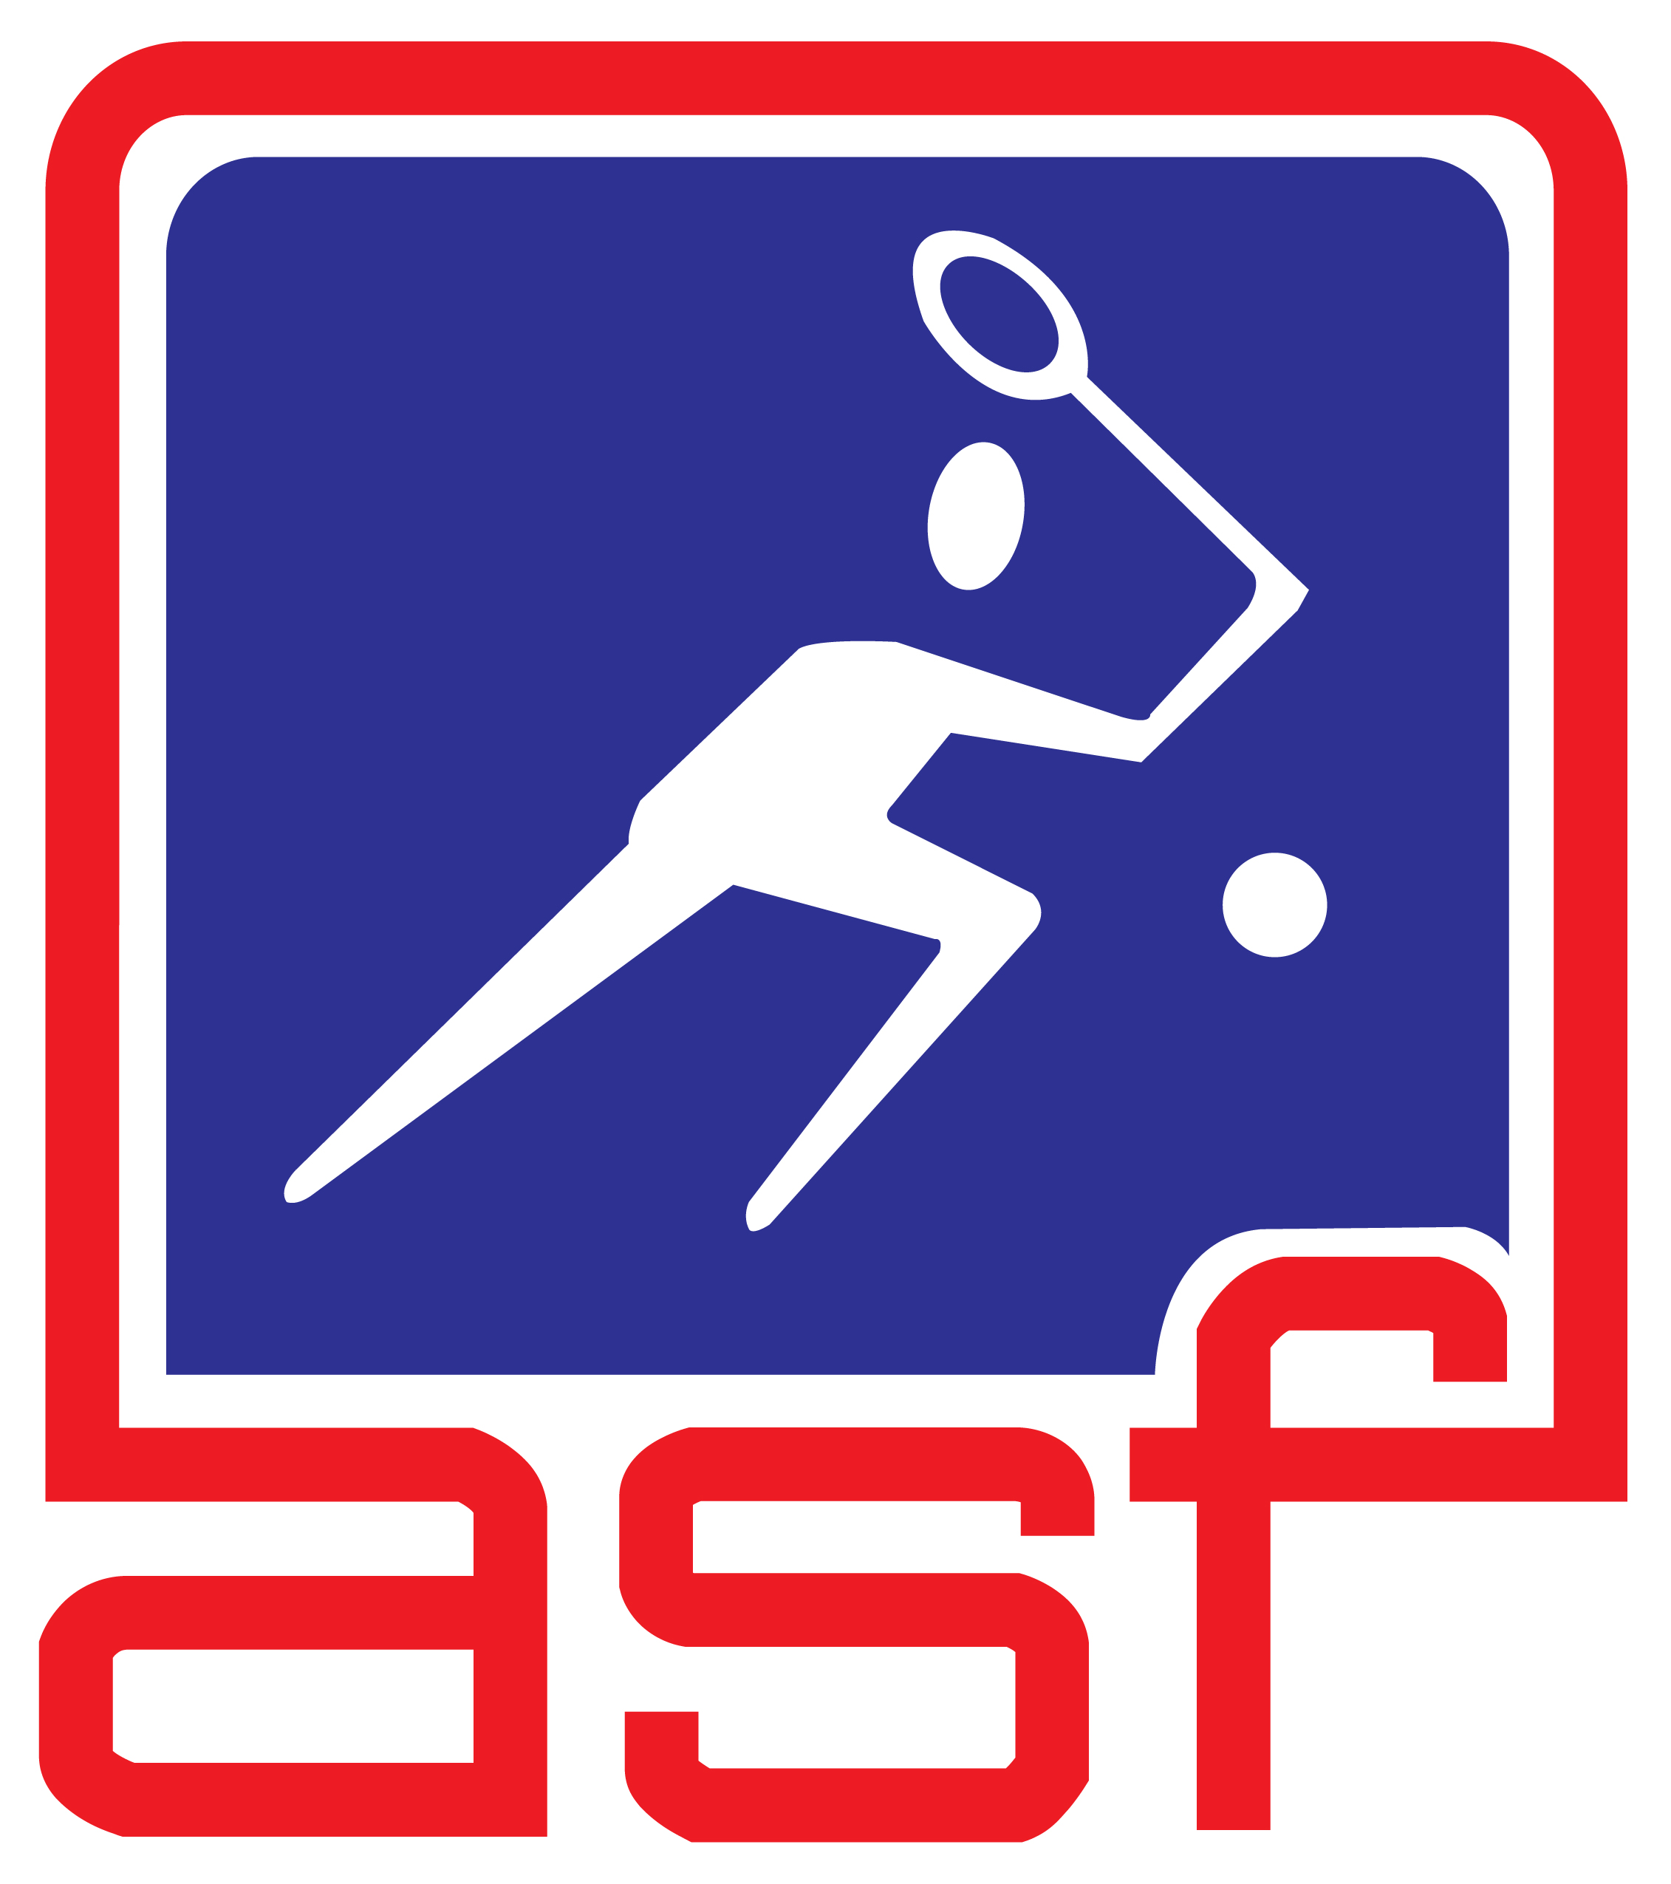 Accredited by ASF as an Asian Junior Super Series
Platinum Event

CHAMPIONSHIP INFORMATION

VENUE

* Astaka Squash Centre, Petaling Jaya, Selangor, Malaysia.
Bukit Bintang School Courts

EVENTS

1. Boys Under 19 Open Championship 6. Girls Under 19 Open Championship

2. Boys Under 17 Open Championship 7. Girls Under 17 Open Championship

3. Boys Under 15 Open Championship 8. Girls Under 15 Open Championship

4. Boys Under 13 Open Championship 9. Girls Under 13 Open Championship

5. Boys Under 11 Open Championship 10. Girls Under 11 Open Championship

PLAYERS ENTER ONE EVENT ONLY.

PLAYERS WILL BE ENSURED OF AT LEAST 2 MATCHES DEPENDING ON THE NUMBER OF ENTRIES FOR THAT AGE CATEGORY

AGE CUT OFF DATE

* The age cut off date for the Championships is 2nd June 2012 (last day of Championship)

ENTRY

It is open to all foreign and local players. All entries must be endorsed by their respective National Associations. Please give your correct date of birth as we will verify them from your Passport.

ENTRY FEE

a. Foreign (With Accommodation/twin sharing) - USD335.00 nett each person inclusive bank
USD$25 charges for Individual Transaction
b. Foreign (Group Transaction - USD310 nett each person
(and to include US25 for bank charges)
c. Foreign (Without Accommodation) - RM 250.00 nett
d. Local - RM 40.00 nett

- Entries and Bank Transfer slip to be emailed. Only payments made directly into the Account Number below will be accepted.

“ ALL STAR JUNIOR SQUASH CHAMPIONSHIP”
Account Number : 514187-121728
Bank : Malayan Banking Bhd.
Wisma IJM, Jalan Yong Shook Lin,
46200 Petaling Jaya, Selangor, Malaysia

SWIFT CODE : MBBEMYKL

* SRA Selangor cannot be held responsible for entries not accompanied with bank transfer.

PLAYER WITHDRAWAL

* Withdrawal from the Championship must be notified to SRA Selangor as soon as possible.
Any withdrawal after the 10th May will be referred to ASF
ENTRY FEE WILL NOT BE REFUNDED AS ROOMS WOULD HAVE BEEN BOOKED.

CLOSING DATE

* Entries must be received by 1200 NOON (M’sian time) ON 15TH April 2012

All Foreign and Local entries to be submitted through their National Federation
All entries should state their respective national age category ranking as it may become a consideration for seeding purposes

LATE ENTRIES OR ENTRIES WITHOUT THE ENTRY FEE WILL NOT BE ACCEPTED.

The ASF Seeding Committee will finalise the seeding and the decision of the Committee shall be final

ACCOMMODATION

* Official Hotel – PJ Hilton Hotel – 5 star hotel.
- The USD310.00 entry fee covers 7 nights accommodation from 27 May to 2nd June only on a twin sharing basis with breakfast for both officials and players. There will be no refund for unused nights. Check out on the 3rd June 2012

- For the single occupancy, the rate is USD620.00 covering 7 nights accommodation from 27 May to 2nd June 2012 with breakfast for both officials and players. There will be no refund for unused nights. Check out on the 3rd June 2012

- Only 10 beds available for TRIPLE SHARING. You have to pay the same amount also even for NON PLAYING KIDS/PARENTS ETC. This is to cover the cost of the bed, breakfast transportation etc. Max 3 person only in ONE ROOM

- For additional nights, booking MUST also be made through the Organisers in order to enjoy the same rate and the charges per night is as follows:
- Single occupancy = US$210
- Twin Sharing = US$110.00 per head

- Accommodation for local players outside Klang Valley will be at Hotel Singgahsana

- The accommodation arrangements for all foreign and local players and officials are subsidised by the organiser.

Please take note that there are only 200 rooms available at this subsidised rate. So it will
Be on a first come first SERVE ACCOMPANY WITH PAYMENTS PLEASE. We will not be able to entertain anybody once all rooms have been taken up.

Should you require a Single Room for your Family, please book directly from the hotel at their prevailing RATES.

TOURNAMENT “T” SHIRTS

* All participants will receive a minimum of 1 tournament “T” shirt.

TRANSPORTATION

* Regular shuttle service between hotel and venue will be provided.

OFFICIAL BALL

* Prince Extender2 Pro

FLIGHT INFORMATION

* All foreign participants are required to fill the flight information form attached if they require transport on arrival and departure. All arrivals/departure (two days before/two days after) at the Kuala Lumpur International Airport (KLIA)/LCCT only will be met.
PLEASE TAKE NOTE THAT TRANSPORT PICK UP /SEND OFF IS ONLY FOR THOSE STAYING AT THE OFFICIAL HOTEL HILTON AND WITH BOOKINGS THROUGH SRAS ONLY

ORGANISER

- The Championship is organised by the MBPJ (Petaling Jaya City Council) and Squash Rackets Association of Selangor.

- Sanctioned by SRAM (Squash Rackets Association of Malaysia).

- Accredited by ASF as an Asian Junior Super Series Platinum Event

TOURNAMENT ORGANISATION:

* Tournament Director: Mr. Kelvin Lim Mobile Phone No: 019-3262813
Tournament Referee: Mr. Henry Tan Mobile Phone No: 013-3385375
Secretariat: Ms. Mary Ong Mobile Phone No: 017-8815066
Accommodation: Ms. Pusppa Mobile Phone No: 016-2866476
Transportation : Mr Zailani Mobile Phone No: 012-2699944
SRAM Technical Delegate: Mr. Peter Chee Mobile Phone No: 012-2123580

ENTRIES

* All players must complete an official entry form with the entry fee slip fax to :

THE TOURNAMENT DIRECTOR, (All Star Junior Squash Championship),
TEL: 603 56116239
OR
maryongtn@yahoo.com

MILO - ALL STAR JUNIOR SQUASH CHAMPIONSHIP 2012
28TH MAY TO 2ND JUNE 2012
PETALING JAYA, SELANGOR - MALAYSIA

ENTRY FORM
Boys Girls
I wish to enter: | (Please tick): |  | Under 19 Championship
 |  |  | Under 17 Championship
 |  |  | Under 15 Championship
 |  |  | Under 13 Championship
 |  |  | Under 11 Championship

FULL NAME:/ SURNAME IN BLOCK PRINT
ADDRESS:
 |  |  |  | POST CODE:
TEL No | Home: |  |  |  | E-mail:
FAX No | Home:

DATE OF BIRTH: DD/MM/YY |  | NATIONAL RANKING:
NATIONALITY:

RECENT RESULTS
OPPONENT | EVENT | DATE | FULL SCORE | W/L

Entry Fee USD310.00- Twin sharing and USD620 for Single occupancy (Inclusive of 7 nights accommodation with breakfast) starts from 27THMay to 2nd June 2012
Only entries with entry fee in the form of BANK TRANSFER payable to:
"All Star Junior Squash Championship".
BANK ACCOUNT NO: MAYBANK, 514187121728
I agree to abide by the Championship Regulations and the SRAM Code of Conduct

* Closing Date: 15th April 2012

SIGNATURE: …………………………………………………… DATE: ……………………………

ENDORSEMENT BY NATIONAL ASSOCIATION

SIGNATURE: ……………………………………… NAME: ………………………………………….

POSITION: …………………………………….… DATE: …………………………………………..

Please forward entry form to:
THE TOURNAMENT DIRECTOR, (All Star Junior Squash Championship),
Tel: 603 56116239
E-MAIL: maryongtn@yahoo.com

MILO ALL STAR JUNIOR SQUASH CHAMPIONSHIP
28th May to 2nd June 2012
PETALING JAYA, SELANGOR – MALAYSIA

ARRIVAL AND DEPARTURE DETAILS

COUNTRY | :
ARRIVAL DATE | : |  |  |  |  | TIME |  | :
FLIGHT NO | : |  |  |  |  | AIRLINE |  | :
MANAGER | :
COACH | :
PLAYERS | :
DEPARTURE DATE |  | : |  |  |  | TIME |  | :
FLIGHT NO |  | : |  |  |  | AIRLINE |  | :
NO OF PAX |  | :

Kindly Email to SQUASH RACKET ASSOC . SELANGOR : not
Later than : 10th May 2012

MILO - ALL STAR JUNIOR SQUASH CHAMPIONSHIP
28th May to 2nd June 2012
PETALING JAYA, SELANGOR – MALAYSIA

PRIZE MONEY IN USD

POSITION | U19 |  | U17 |  | U15
 | BOYS | GIRLS | BOYS | GIRLS | BOYS | GIRLS
1 | 1200.00 | 1000.00 | 500.00 | 300.00 | 200.00 | 150.00
2 | 800.00 | 700.00 | 300.00 | 200.00 | 170.00 | 120.00
3 | 600.00 | 500.00 | 200.00 | 150.00 | 150.00 | 100.00
4 | 450.00 | 400.00 | 150.00 | 125.00 | 100.00 | 70.00
5 | 350.00 | 300.00 | 125.00 | 100.00 | - | -
6 | 250.00 | 200.00 | 100.00 | 75.00 | - | -
7 | 200.00 | 150.00 | 75.00 | 50.00 | - | -
8 | 100.00 | 100.00 | 50.00 | 40.00 | - | -

Prize money will only be given to Top 8 winners in the U/19, & U/17 and Top
4 winners in the U15.

The rest of the winners will receive valuable prizes in the form of sports
equipment.

Prize Money is tax exempt.

ASF Code of Conduct

The following offences may be subject to penalties under Rule 17 of the International Singles Game of Squash and of the International Doubles Game of Squash, and/or be subject to disciplinary action by the ASF Disciplinary & Appeals Committee:
AB1. A participant who verbally or physically abuses his opponent, the Marker, Referee, officials, spectators or sponsors.
AB2. A participant who shows dissent to the Marker, Referee or officials, including foul or profane language and obscene or offensive gestures.
AB3. A participant who abuses playing equipment or the court.
AB4. A participant who fails to comply with the conditions of entry of a championship including any rules with regard to clothing or advertising.
AB5. A participant who having entered a championship or accepted an invitation to play withdraws from the event or fails to attend.
AB6. A participant who fails to complete a match for a reason other than injury, illness or emergency situation.
AB7. A participant who defaults from a championship. The Disciplinary & Appeals Committee may require evidence or proof of ‘bona fide’ injury, illness or other emergency situation.
AB8. A participant who fails to make himself available to meet reasonable request for interviews by the media.
AB9. A participant who does not comply with the Rules or spirit of the Game.
AB10. A participant guilty of any other unreasonable conduct which brings the Game into disrepute, including behavior as a result of intoxication by any means including recreational substances such as alcohol, marijuana and hallucinogens.

ASF CLOTHING REGULATIONS

The following clothing regulations shall apply without exception to all ASF Championships.

1. In all matters of judgment or opinion arising from the interpretation of this clothing rule the decision of the Championship Referee shall be final, except that he may not rule illegal or unacceptable an item of clothing or a design which has been approved by the ASF.

2. Playing clothing for men shall consist of a short-sleeved shirt, shorts, socks and playing shoes. Playing clothing for women shall consist of a shirt worn with a skirt or shorts, or a dress, socks and playing shoes. Other garments, such as part or all of a tracksuit, may be worn during play with the permission of the referee.

3. All clothing worn during practice as well as during match play shall conform to the accepted standards of decency and cultural/religious tradition of the Host Country, as adjudged by the Championship Referee.

4. For any match covered by television, players’ clothing shall conform to the advertising regulations published and generally applied by the appropriate television authority of the Host Country.

5. Players may wear clothing of any color or combination of colors.

6. Shirts or tops may carry:
a. The manufacturer’s normal trademark, symbol or name on one breast - the display to be contained within an area not exceeding 20 square centimeters in total and 10 centimeters in any one dimension.
b. Identification, in areas clearly separated from each other, on the opposite breast to the manufacturer’s symbol and/or on each arm, as follows:
i) Three sponsors’ displays - each to be contained within an area not exceeding 40 square centimeters in total and 10 centimeters in any one dimension;
OR
ii) Two sponsors’ displays and one national identification badge - each to be contained within an area not exceeding 40 square centimeters in total and 10 centimeters in any one dimension.
c. A national or club identification title, plus a sponsor’s identification if required, on the back of the shirt or dress; the whole to be contained within an area not exceeding 300 square centimeters. The player’s name may also be displayed within an area not exceeding 150 square centimeters.

7. Shorts or skirts shall be of design normally approved and used for Squash.

8. Shorts or skirts may carry:

a. The manufacturer’s normal trademark, symbol or name on one side or leg, contained within an area not exceeding 10 square centimeters in total.
b. One sponsor display on the opposite side or leg from that in F8a, contained within an area not exceeding 20 square centimeters in total and 10 centimeters in any one dimension.

9. Socks shall be of any color or combination of colors and each may carry one manufacturer’s normal trademark, symbol or name contained within an area not exceeding 10 square centimeters in total and 10 centimeters in any one dimension.

10. Shoes shall be of any color or combination of colors and have a non-marking sole. Each shoe may carry one manufacturer’s normal trademark, symbol or name in not more than two areas, not exceeding in total 10 square centimeters.
11. Tracksuits may be of any design and color and are subject to no advertising restrictions, unless worn during play when the restrictions under F6 above shall apply to the jacket and under F8 above shall apply to the trousers.

12. The wearing of headwear is permitted provided it is not so conspicuous or brightly reflective as to distract or unsight an opponent and shall not be pinned in a potentially dangerous manner. Headbands and straps for approved protective eyewear may carry one manufacturer’s normal trademark totally contained within an area not exceeding 40 square centimeters or 10 centimeters in any one direction.

13. Wristbands may carry one manufacturer’s normal trademark totally contained within an area not exceeding 10 square centimeters.

14. Any jewelry or watches worn by a player shall not be so conspicuous or so brightly reflecting as to distract or unsight an opponent and shall not be potentially dangerous.

15. The sponsor(s) of any tournament shall have no automatic right of exposure on a player’s clothing unless such exposure is stipulated on the entry form.

16. Where the manufacturer of clothing is also the sponsor of the player or team wearing the clothing he shall additionally be allowed to utilize some or all of the advertising space granted to sponsors.

17. MNAs are advised to ensure that their contracts with individual players specify that selection will require the use of national team kit in team events and that players’ personal sponsors have no right of exposure on such kit.

